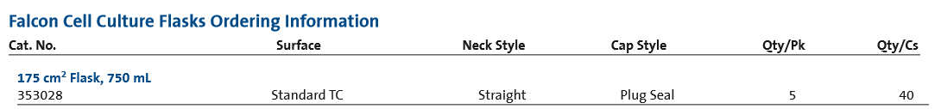

Qty Required: **4000PCS**

